EXPERIMENT 18
Implement Image Cropping, Copying and Pasting to Select a Region of Interest (ROI) Using OpenCV
Aim:
To crop, copy and paste a selected region of interest (ROI) from an image using OpenCV.
Procedure:
- Import the OpenCV library.
- Read the input image.
- Select the required region using array slicing.
- Copy the selected region.
- Paste the region into another location.
- Display the final image.
Program:
import cv2

img = cv2.imread('image.jpg')

roi = img[50:200, 50:200]
copy = roi.copy()

img[250:400, 250:400] = copy

cv2.imshow('Cropped Image', roi)
cv2.imshow('Final Image', img)

cv2.waitKey(0)
cv2.destroyAllWindows()
Input:

Output:
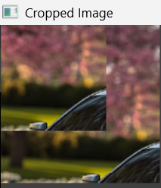
Result:
Thus, image cropping, copying and pasting were successfully performed using OpenCV.

